Access Modifiers in Java
In Java, Access modifiers help to restrict the scope of a class, constructor, variable, method, or data member. It provides security, accessibility, etc to the user depending upon the access modifier used with the element.
Types of Access Modifiers in Java
There are four types of access modifiers available in Java:
- Default – No keyword required
- Private
- Protected
- Public

1. Default Access Modifier
When no access modifier is specified for a class, method, or data member – It is said to be having the default access modifier by default. The data members, classes, or methods that are not declared using any access modifiers i.e. having default access modifiers are accessible only within the same package.

2. Private Access Modifier
The private access modifier is specified using the keyword private. The methods or data members declared as private are accessible only within the class in which they are declared.

3. Protected Access Modifier
The protected access modifier is specified using the keyword protected.
The methods or data members declared as protected are accessible within the same package or subclasses in different packages.

4. Public Access Modifier
The public access modifier is specified using the keyword public.
- The public access modifier has the widest scope among all other access modifiers.
- Classes, methods, or data members that are declared as public are accessible from everywhere in the program. There is no restriction on the scope of public data members.
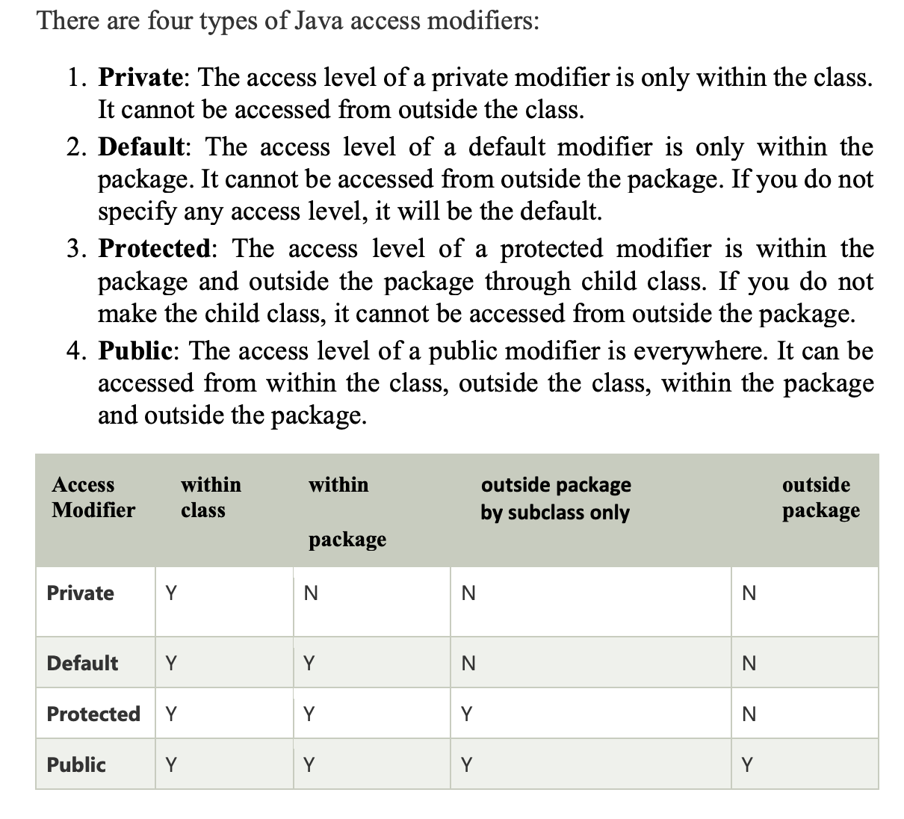

1. What are access modifiers in Java?
Access modifiers in Java are the keywords that are used for controlling the use of the methods, constructors, fields, and methods in a class.

2. What is void in Java?
Void in Java is used to specify no return value with the method.

3. What are the 12 modifiers in Java?
12 Modifiers in Java are public, private, protected, default, final, synchronized, abstract, native, strictfp, transient, and volatile.

